Phillip Island Nature Parks is committed to offering enjoyable nature-based experiences and has a range of accessible facilities available for all visitors. This following information aims to accurately describe the facilities and services that are offered at the Koala Conservation Reserve.

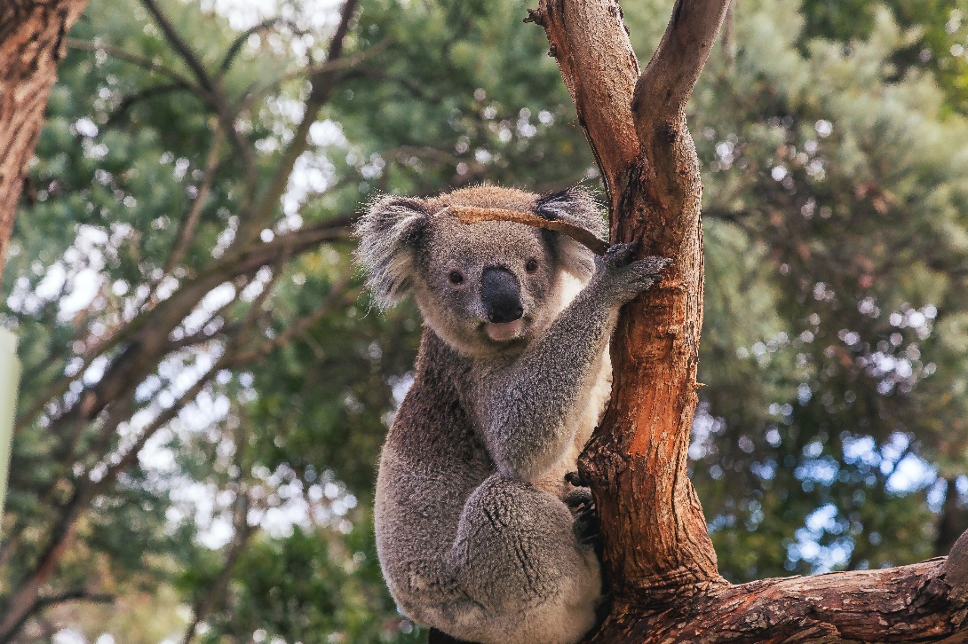
Koala in its natural habitat at the Koala Conservation Reserve
PRE-ARRIVAL INFORMATION
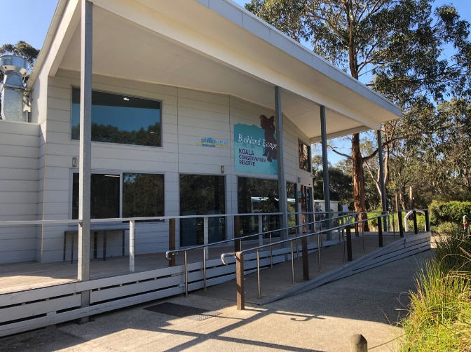
Visitor Centre entrance
The Koala Conservation Reserve offers a range of family-friendly activities and opportunity to explore lush native bushland and see iconic Australian wildlife in their natural habitat.
You can wander the tree-top boardwalks to see the koalas up close in their natural habitat. You can also take a walk through the woodlands and enjoy the abundant birdlife, wallabies and echidnas.
Tickets
The Koala Conservation Reserve is open daily, opening times change throughout the year. You can find current opening hours at Koala Conservation Reserve » Phillip Island Nature Parks
This is a ticketed experience, and everyone aged 4 years old and over requires a ticket to enter. Companion and Carer cards are recognised, and concessions do apply for card holders.
ARRIVAL INFORMATION
Carpark
The Koala Conservation Reserve is located 90 minutes drive from Melbourne on Phillip Island. Allow a further 15 minutes from when you cross the bridge onto Phillip Island to get to the Koala Conservation Reserve. There is free parking on site, including a section set aside for accessible parking. This section is clearly marked by elevated signs. The ground cover is hard-packed gravel. The spaces are not individually marked out.
The parking area is approximately 50 metres from the Koala Conservation Reserve Visitor Centre ramped entrance. The path to the entrance is generally flat over hard-packed gravel.
As you move to the outdoor area, you will pass through an information section. There are interpretive displays that are accessible from a wheelchair.
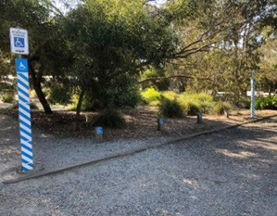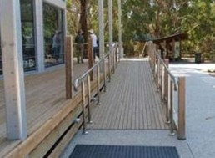
Signposted accessible parking area Ramp access to the visitor centre

Reduced Mobility
The Koala Conservation Reserve is made up of indoor and outdoor attractions. There is one access point which is the visitor centre. There is a wide ramp with 1 in 14 gradient and handrails on both sides. There is a complimentary wheelchair available for use.
The outdoor area is linked with wide paths and boardwalks. Outdoor surfaces range from hard-packed gravel paths, timber, concrete, raked pavers and bitumen, with timber laminate and tiles on internal floors.

The Visitor Centre
The visitor centre includes a ticketing area and a café where you can buy souvenirs and refreshments. There are also tables and chairs. The souvenir area is well laid out with wide aisles and most stock within easy reach.
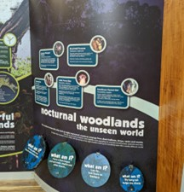
Accessible Interpretive Displays
The Boardwalk
The treetop boardwalks are wheelchair accessible and allow close-up koala viewing. The access to these boardwalks is via large heavy gates with handles set at 1300mm high. Gates are at both ends of the boardwalks.
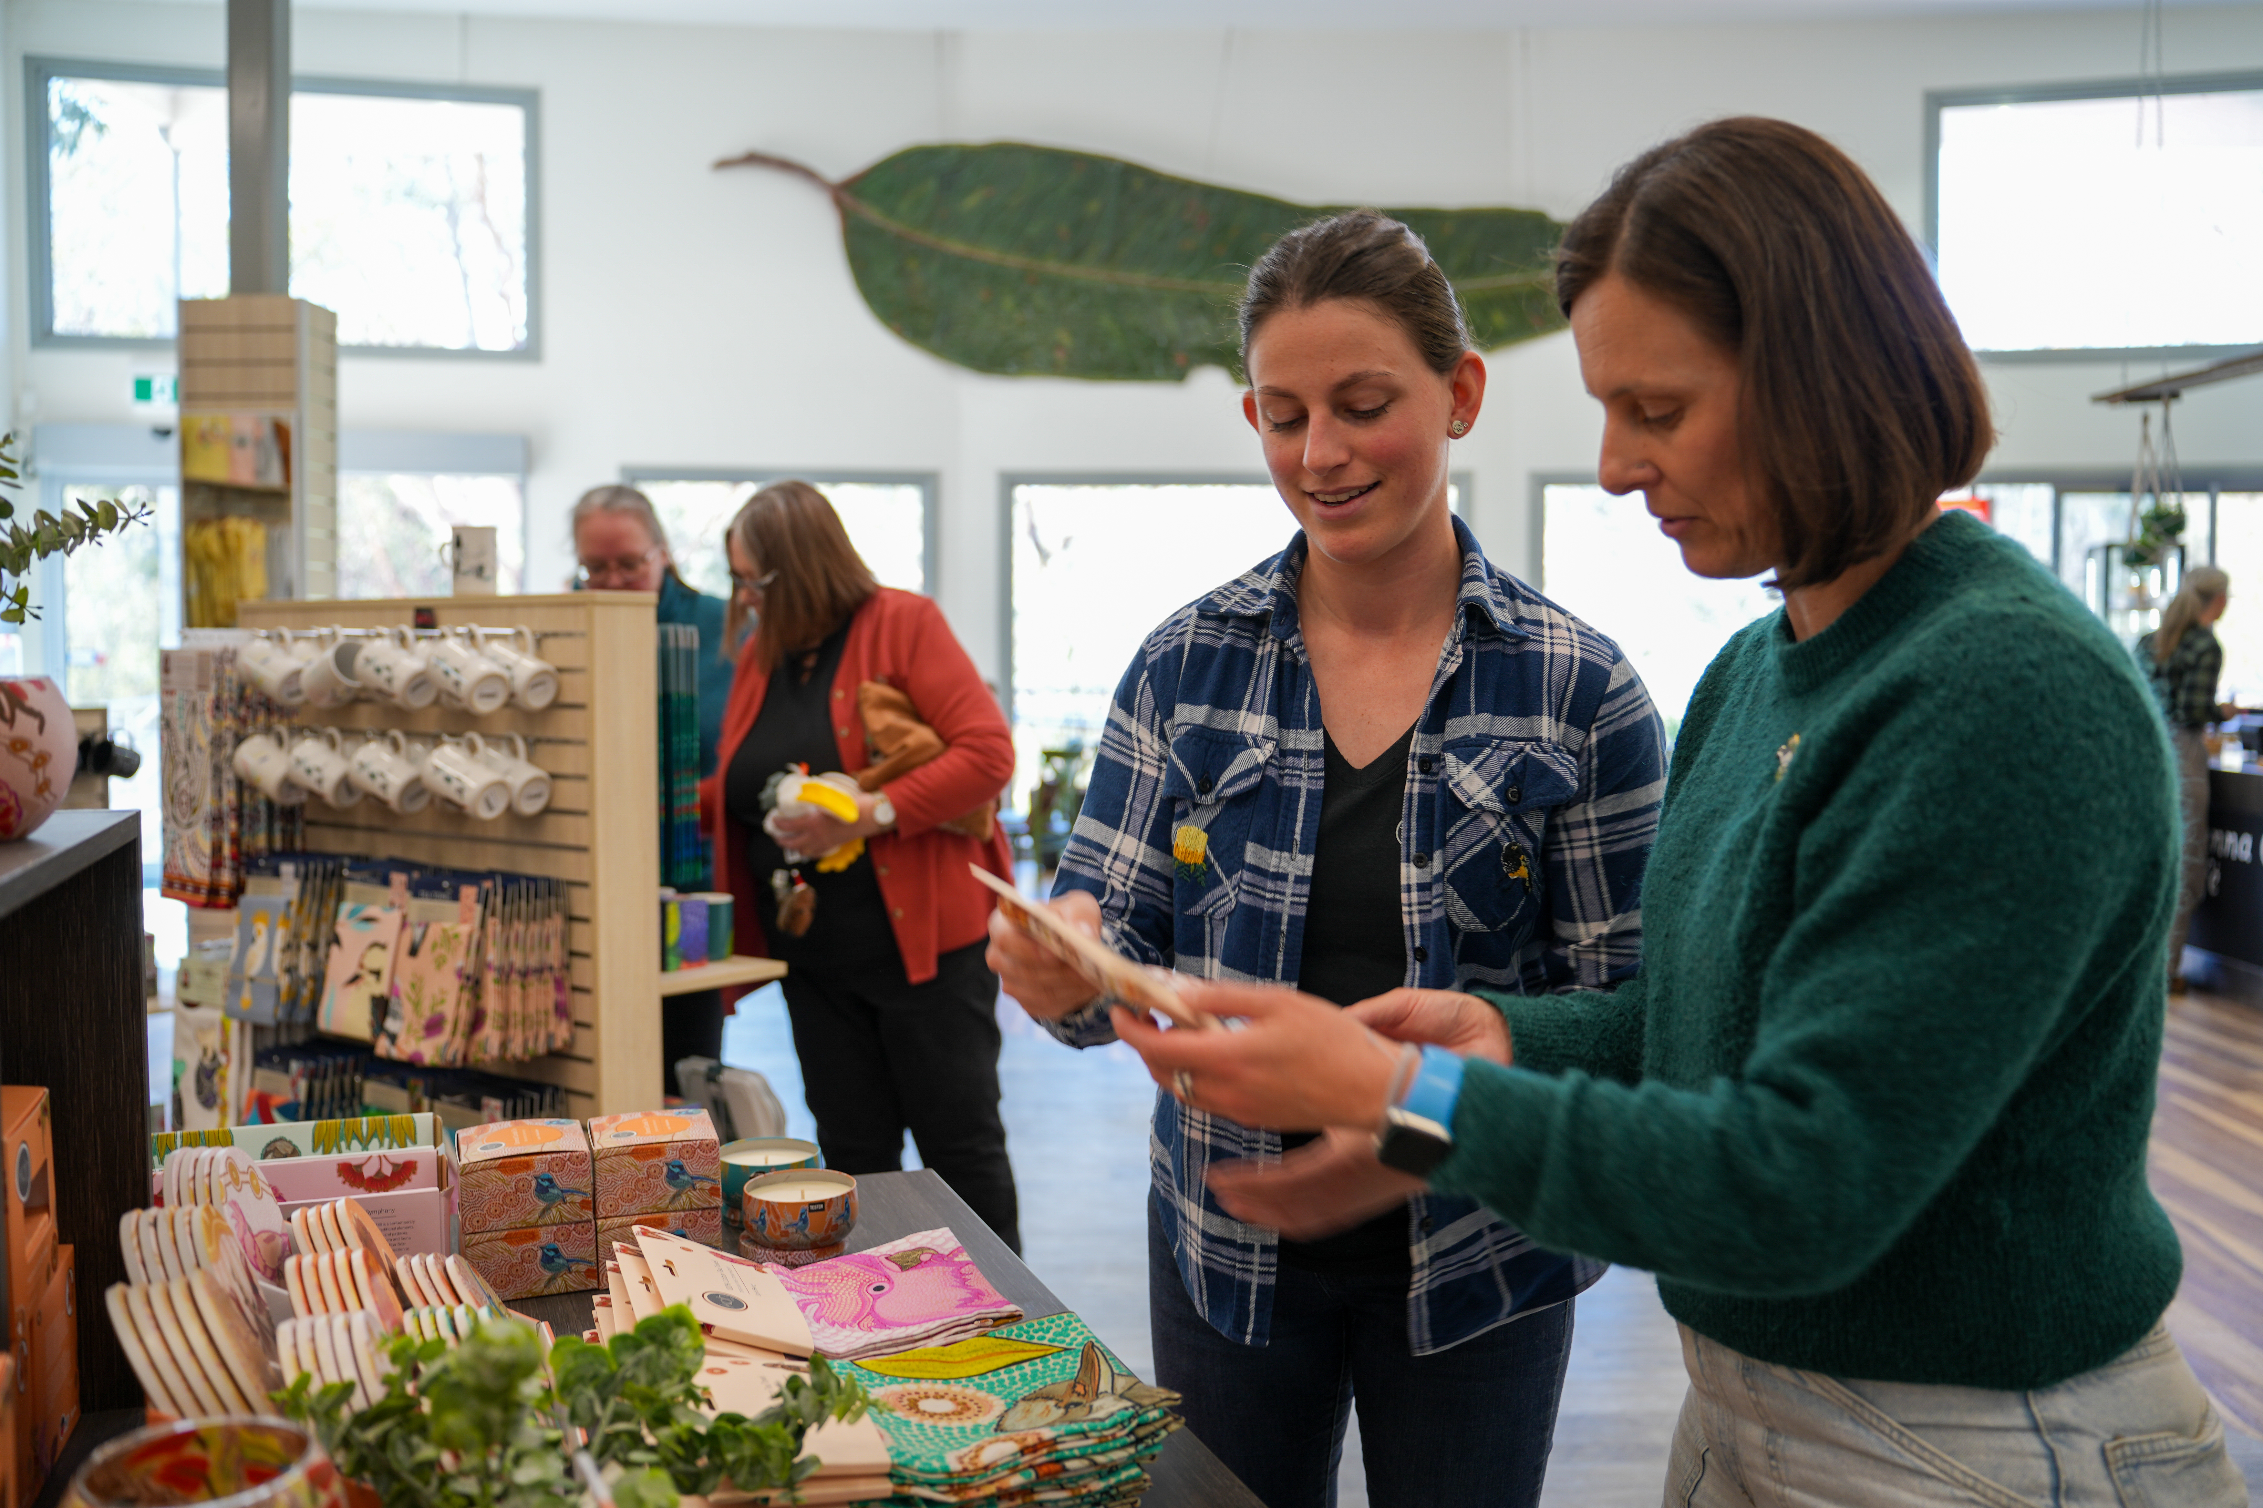
Souvenirs within reach

Manna Gum Café
Enjoy the delicious food with native bush flavours and coffee.
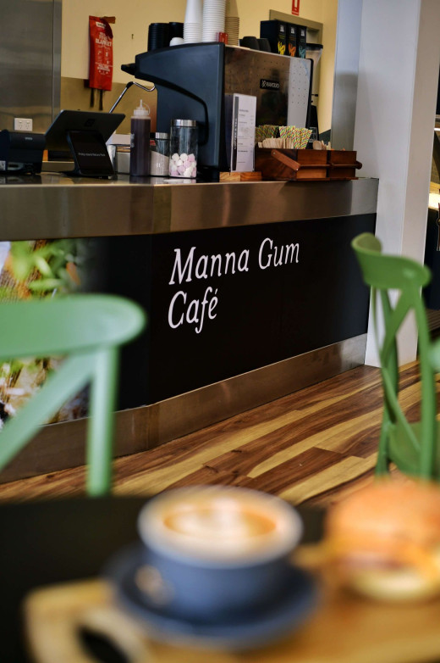
Amenities
There are two sets of toilets at the Koala Conservation Reserve.
One is located at the end of the deck outside of the visitor centre and another inside the building.
Neither meet with today’s standards, although they do have some accessibility features such as grabrails.
There is an accessible toilet located outside the building, to the left of the visitor centre entrance. It is more spacious and easier to access than the inside toilet.

Sensory Guide
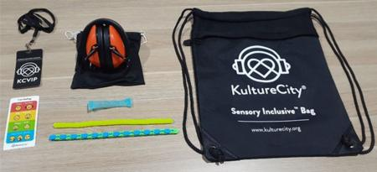

We are a certified sensory-inclusive site with professionally trained staff. Sensory bags are available, equipped with noise-cancelling headphones, fidget tools and verbal cue cards. Weighted lap pads are available. The bags and lap pads can be checked out for free by leaving an ID with our staff.
There are Headphone Zones and Designated Quiet Areas in the visitor centre.
While at the Koala Reserve you may experience:

Feel | Sounds | Sights | Smells
Different ground surfaces | People | Bright lights and glare | Disinfectants
Shared personal space | Audio presentations | Glare | Nature
Weather; wind, rain | Animals | Reflections | Animals
 | Wind | Animals
 | Traffic and machinery | Trees and plants

Contacts
Koala Conservation Reserve
1810 Phillip Island Road,
Phillip Island, VIC 3923
www.penguins.org.au

Communication Board

You can print and take this Communication Board with you when you visit the Penguin Parade.
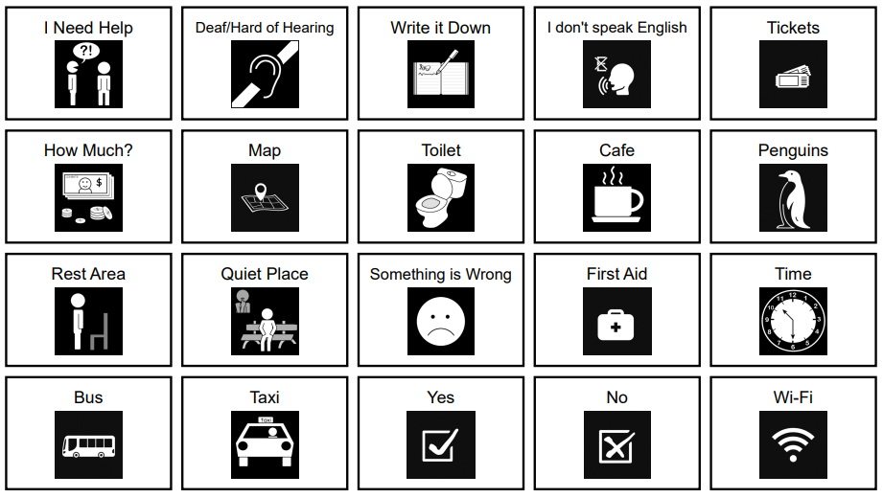
© Inclusive Tourism Pty Ltd, All Rights Reserved. 2022 Owned and developed by Inclusive Tourism Pty Ltd www.InclusiveTourism.com.au

